Qiuying Li

Project 1

9070196135

1. (a) & (b)

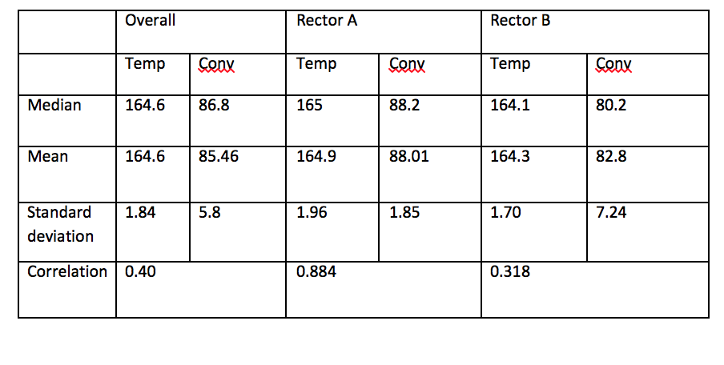

1.(c) Comparative histograms of temperature and conversion, by reactor.

